Pokhara University

Level: Bachelor | Semester – Fall | Year : 2012
Programme: BE |  | Full Marks: 100
Course: Mathematical Foundation of Computer Science |  | Pass Marks: 45
 |  | Time : 3hrs.

Candidates are required to give their answers in their own words as far as practicable.
The figures in the margin indicate full marks.

Attempt all the questions.

 | - Prove or disprove: “A complete graph with 5 vertices cannot be a planar graph”  - State and explain the different ways of computer representation of graph. | 8  7
 | - State and prove Euler’s formula for planar graph  - Find the shortest path from a to z in the graph shown in figure using DIJKASTRA'S algorithms.  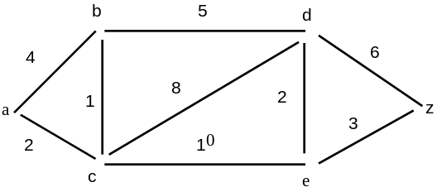 | 7  8
 | - Show that p ↔ q and (p → q) ^ (q → p) are logically equivalent.  - What is "proof by induction"? State and explain the principle of mathematical induction. Why mathematical induction is valid? | 7  8
 | - Give an argument using rules of inference to show that the conclusion follows from the hypothesis:  If you send me an email message then I will finish writing the program. If you do not send me an email message, then I will go to sleep early and if I go to sleep early then I will wake up feeling refreshed.  Conclusion: If I don't finish writing the program then I will wake up feeling refreshed.  - If an integer a is such that a - 2 is divisible by 3 than a²-1 is divisible by 3. Prove it by using direct proof method. N | 8  7
 | - Define recurrence relation. Find an explicit formula for Fibonacci numbers.  - What is the solution of the recurrence relation  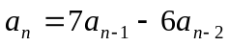 with initial conditions a₀ = 1 and a₁ =6? | 8  7
 | - Explain different types of grammar. Determine whether the following grammar is context sensitive, context free, regular, or none of these. G= (V, Σ , R,S) where 8]  Σ = {a,b}, V= ( S,A) and R consists of→  S→ bS, S→aA, A→aS , S→b, A→ a  - Draw the transition diagram of finite state machine, 7]  I = {a,b,c} O = {0,1,2}  S = { σ₀ , σ₁ , σ₂ , σ₃ } | 8  7
 | Write short notes on any two:  - Application of Graph  - Rule of inference  - Predicate and Quantification | 2×5

